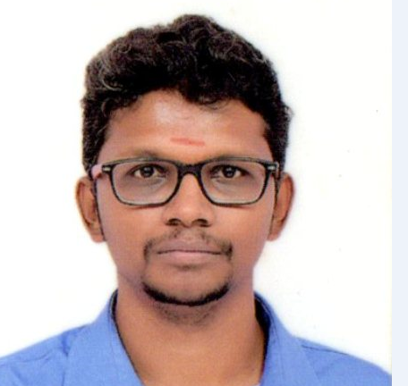
M DEEVAN SUNDER PAUL
No 26,4th Cross NK Palya Shivajinagar Bangalore 560051
Email: - deevanpaul@yahoo.com
Contact: - 7760598532
D.O.B.:- 11-04-1988

OBJECTIVE

Seeking a career in a professionally managed organization providing an environment that encourages continuous learning and enables to take up challenges so as to achieve professional and personal growth.

QUALIFICATIONS

Class | Yr. of Passing | % marks | School/College – Board/ University
B.COM | 2011 | 54% (1-6) | St Josephs Evening College (Autonomus) .  (Affiliated to Bangalore University)

EXPERIENCE

9years of work experience In that 4.5yeras as a ‘Processing Officer’ in IN SOLUTIONS GLOBAL PVT LTD from 01.06.2011 to 10.11.2015.for 3.9 years from 16.11.2015 to 19.07.2019 worked in Xchanging (now renamed as DXC Technology) as Senior Assistant Claim Examiner,from 01.08.2019 till 04.03.2020 was working with AXA Business Services as Specialist.

In ISG.

Served as outsourced officer in 3 nationalized banks

1 Corporation bank - Merchant acquiring cell (dept)
2 Syndicate bank - Atm Dispute (dept)
3 Vijaya bank - Atm Dispute (dept)

In xchanging-

- Worked as outsourced account handler to AON (London)

In AXA Business Services

Worked as specialist account handler Axa Insurance (Singapore)

Trained in ISG – a NFS Network
b Visa Network
c Master Network

In Xchanging-
Insurance technical accounting
worked in accounts receivable and payable
Client premium collection of funds
Cash allocation in our books
Client chasing for funds
funding client based on proper orders and documents
Claim settlements payments to the client
writing emails or call to onshore clients for any assistance or query

Axa Business Services

Insurance technical accounting
worked in accounts receivable and payable
Client premium collection of funds
Cash allocation in our books
Client chasing for funds
funding client based on proper orders and documents
Claim settlements payments to the client
writing emails or call to onshore clients for any assistance or query

Role:
Handling Accounts & Finance department and related queries

Responsibilities:

- Handling of debits and credits from the customer account for all the atm transactions done by the customer.
- Reconciling the all the ATM (Automatic Teller Machine) and POS (point of sale) transactions and tallying the GL on daily basis.
- Maintaining the balance sheet of the company
- Calculating the interest paid to the customer by bank and penalty paid by the customer to the bank.
- Preparing quarterly GL report for auditing purpose
- Communicating with the customer and solving their complaints ie dispute raised by the customer at the time of ATM and POS transaction.
- Educating the customer along with branch for the changes done in the functionality of bank as per the guidelines of Reserve Bank Of India.
- Handling insurance process
- Allocation of cash
- Client chasing
- Client claim settlement
.

Achievements –
Customer Appraisals, Bank Appraisals and Company Appraisals

Technical Skills

IT Exposure:

Operating System familiar with: Windows XP, Windows 7, (Only at the user level).
.
Databases and other skill: .

Other Activities

- Attended soft skill classes, campus visit from spark program in Infosys.
- Attended inter college level seminar on Business Economics.
- Actively participated in Sports activities in schools, colleges.
- Participated in district level sports meet in school days.
- Trained in piano.
- Part of students council vice sports captain in college days.
- Practiced karate in school level.

Achievements –
Awarded yellow belt in karate in school days
Stood 2nd place in inter school relay men in school level
Stood 1st place in 400mts running race men single in school level
Stood 2nd place in high jump men single in school level

Personal Details
Gender : Male
Date of Birth : 11 April 1988.
Hobbies : Problem solving, Listing to music, Playing instruments
Strength : Hard Working, Self Confidence, Good Adaptability
Languages Known : English, Kannada, Telugu, Hindi and Tamil.

Place: Bangalore
Date:29-07-2020 ( M. Deevan Sunder Paul)

